13.95: a) The net force on the block at equilibrium is zero, and so one spring (the one with 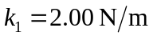) must be stretched three times as much as the one with 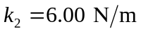. The sum of the elongations is 0.200 m, and so one spring stretches 0.150 m and the other stretches 0.050 m, and so the equilibrium lengths are 0.350 m and 0.250 m. b) There are many ways to approach this problem, all of which of course lead to the result of Problem 13.96(b). The most direct way is to let 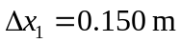 and 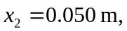 the results of part (a). When the block in Fig.(13.35) is displaced a distance x to the right, the net force on the block is

From the result of part (a), the term in square brackets is zero, and so the net force is 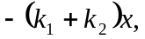 the effective spring constant is 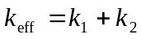 and the period of vibration is 